Software Requirements Specification
for
OMMCOM News
Version 1.0

Luminous Infoways Pvt. Ltd.
Address: N6-373, IRC Village,
Bhubaneswar - 751 015, Odisha, India
Phone: +91 674 2360573, +91 674 6451236
Fax: 91 674 2360724
Web: http://luminousinfoways.com

Revision History
Revision | Revision Date | Description of Change | Author/Modifier
1.0 | 07/04/2016 | Initial Draft | Satyakam Misra

Approval History
Version (x.y) | Prepared By | Reviewed By / Date | Approved By / Date
1.0 | Satyakam Misra | OMMCOM Media / 08/04/2016 | OMMCOM Media

Table of Contents
Revision History i
Approval History i
Table of Contents iii
1. Introduction 1
1.1 Purpose 1
1.2 Document Conventions 1
1.3 Intended Audience and Reading Suggestions 1
1.4 Product Scope 1
1.5 References 1
2. Overall Description 2
2.1 Product Perspective 2
2.2 Product Functions 5
2.3 User Classes and Characteristics 6
2.4 Operating Environment 6
2.5 Design and Implementation Constraints 6
2.6 User Documentation and Training 6
2.7 Assumptions and Dependencies 7
2.8 Solution Constraints 7
3. External Interface Requirements 7
3.1 User Interfaces 7
3.2 Hardware Interfaces 8
3.3 Software Interfaces 8
3.4 Communications Interfaces 9
4. System Features 10
5. Non-functional Requirements 31
5.1 Performance Requirements 31
5.2 Backward Compatibility Requirements If Any 31
5.3 Safety Requirements 31
5.4 Security Requirements 31
5.5 Business Attributes 31
5.6 Software Quality Attributes 31
6. Verification 32

7. Other Requirements 32

8. Analysis Model 32

9. To Be Determined List 32

Introduction

Purpose
Now a day’s people are too busy with their day to day works, they hardly even get chance to look into the news in details. In fact all wish to be get updated on “What’s going now around”? In politics, sports, e.t.c. Considering these situations, OMMCOM Media Private Limited has planned to launch a “friendly app” for everyone. The new friendly app will convey latest happenings to all mobile users on fly. The abstract objectives are:
- App to all:
    - Anyone can install the mobile app on the fly
    - Anyone can post comments, participate in live video conferences
    - Anyone can be a citizen journalist and participate in the good cause
- News to all:
    - View the latest happenings (breaking news)
    - Users shall be able to view news under every category e.g. sports, politics, entertainment, etc.
    - Can share their views and images/videos using Citizen Journalist feature
    - Viewers can participate in live video conference

Document Conventions
This document is written following IEEE 830 standards.

Intended Audience and Reading Suggestions
The different types of reader that the document is intended for are OMMCOM authorized officials, developers, project managers, marketing staff, users, testers, and documentation writers.

This document contains the functionalities for a news portal which is to be implemented for OMMCOM Pvt. Ltd. 's in both web & mobile app.

Product Scope
This document showcases OMMCOM's Media Pvt. Ltd. Web & mobile app which makes it easier for the viewers to read news on the fly and participate in live video conferences as well. Viewers shall be able to post their comments for any news/videos and share any news/videos in social media with ease. Elicited the requirements through meetings, client interviews, observation & market research.

References
- IEEE 830 standard template
- Concept Note on Mobile Application & Web Portal for OMMCOM Media Pvt. Ltd.

Overall Description
The general factors are described here affect the product and its requirements. This section does not state specific requirements. Instead, it provides a background for those requirements, which are defined in Section 4, and makes them easier to understand.

Product Perspective

System Interfaces
To use OmmCom Web & mobile app to its full utility the following system interfaces are required.

Specification | Description
Web Browser | Microsoft Internet Explorer v9.0 or higher.  Mozilla Fire-Fox v12.0 or higher.  Google Chrome v27.0.1453.116m or higher.
Mobile App | Viewers shall be able to download the app from Play Store & App Store.
Mobile Camera | For Video Conference using mobile app
Web Camera | For Video Conference using Web App
Internet Speed | 25 kbps or more

Interfaces

- Viewers shall be able to use services both via web & mobile interface.
- Viewers shall be able to participate in video conference using there mobile devices and their web cameras as well.
- Viewers can request to join a live video conference only if the Internet speed is 25 KBPS or more.
- OMMCOM journalists can use Digital Camera and integrate it to their laptops or desktops.
- OMMCOM app will be supervised and routed through the live media streaming server and a web server.
- RTMP (Real Time Messaging protocol), WEB RTC to capture video and audio frames from browsers/web-components and transmit/broadcast it immediately.
- “Video Capture Card” to be used to capture data in digital camera and save it at Laptop/Desktop (through composite or HDMI).

Hardware Interfaces

- Hosting Server Configuration (Minimum System Requirements):

Specification | Particulars
Operating System | Ubuntu 14.X server
Web Server | Apache 2.X
Server | Media Streaming Server, Web Server
RAM | 4 GB
Processor | Intel Quadcore
Storage | 1 TB
Connection Type | Intranet LAN

Software Interfaces
Software:
- Client Side Scripting
        - HTML 5
        - CSS 3
        - JQuery
- Server Side Programming
        - PHP 5.X
        - Laravel 5.X (MVC Pattern)
  - Mobile App Development
    - Native + Hybrid
Database:

- MySQL 5.X

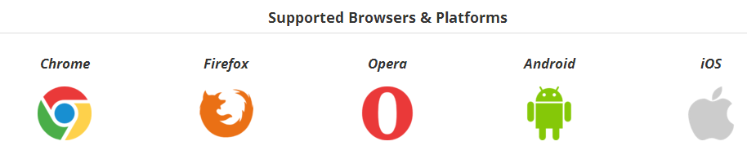

Communication Interfaces

The Live recording by a HD camera, shall be connected to a PC using Captured Card. The live stream video from Mobile as well as PC is being auto-streamed to Media Streaming Server. The live stream video from Media Streaming is auto-streamed to Web Server which is then broad casted in mobile app and web browsers.
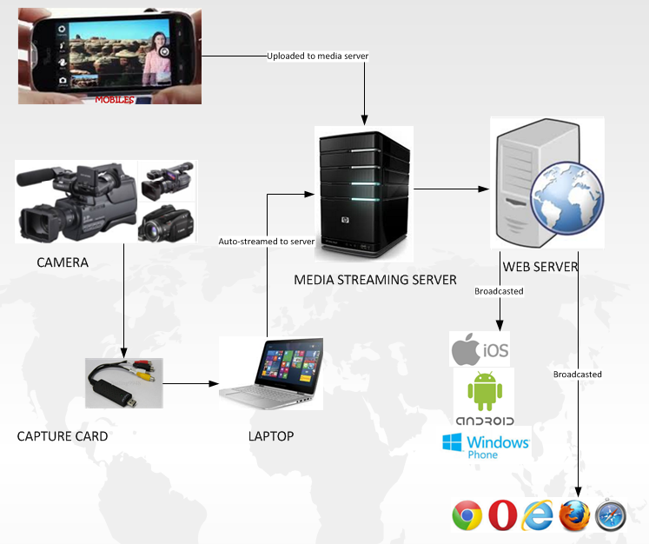

Product Functions

Sl. No. | Particulars
1 | Landing Page (Web)
2 | Landing Screen (Mobile)
3 | Role Management (Web)
4 | User Management (Web)
5 | Content Management System (CMS) (Web)
6 | Video Conference (Web)
7 | Social Media (Web)
8 | Audit Trail (Web)

User Classes and Characteristics
- Admin
        - Can configure all master records at web portal
        - Can create manage news, videos, etc. at web portal
- Content Writer
        - Can write content to be published after admin's approval
- Viewers
        - Can View the news, videos, etc. of the web portal
        - Can take part in Video Conference
        - Can post comment on any news, video, etc.
        - Can share any news, videos, etc. in social media
        - Can use the citizen journalist feature.
- Other dynamically created users

Operating Environment
- User will access the application from a computer by using browser as the platform.
- User will access the application using mobile app.

Design and Implementation Constraints
- User needs to have battery backup/electricity & Internet connectivity to access the application in web.
- User needs to have required battery charge in their respective mobile device and Internet connectivity to use the mobile app.

User Documentation & Training
- CCB [Satyakam Misra(System Analyst), Debasish Mishra(Project Manager)]
- SRS
- User Manual
- UAT document
- Test Report(s)
- QMS Training
- Business Analysis Training

Assumptions and Dependencies
- Internet Connectivity required to view the updated information in web/mobile application
- Electricity should be available for accessing the web app.
- Web camera / Mobile's camera required for the visitors to participate in video conference.
- Internet connectivity of 25 kbps or more is required for a visitor to join live video conference.

Solution Constraints
- Number of participants simultaneously joining Video conference would be limited beyond which it might become slower.

External Interface Requirements

User Interfaces

What Admin can do?
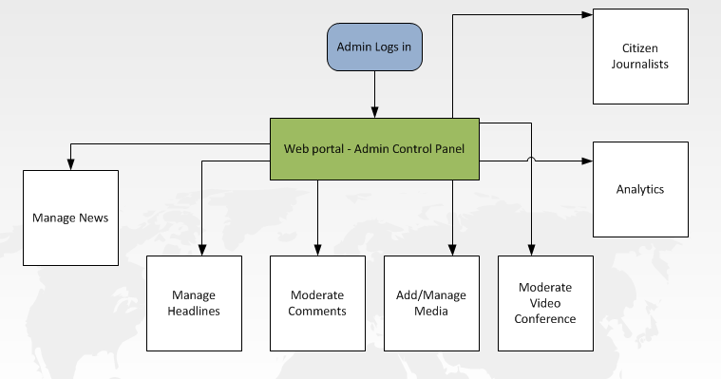

Broadcasting of news
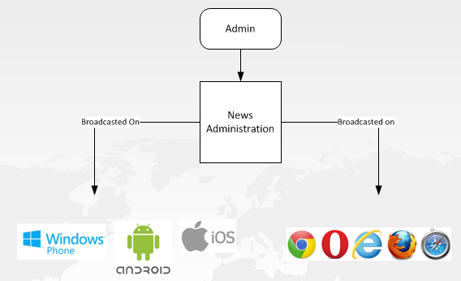

Hardware Interfaces
Ommcom web application will use the standard input/output devices for personal computer and a Ommcom's mobile app requires a smart phone (android & ios).

- Keyboard
- Mouse
- Monitor
- Smart Phone
- Web Camera
- Digital Camera
- Video Capture Card

Software Interfaces
- Both web & mobile application will share the same common database resulting in the same content across both platforms.

Communication Interfaces
- Emails shall be sent to the users accessing the CMS module in-case of forgot password.
- Emails shall be sent to Citizens whenever there is any progress regarding the content they have shared with OMMCOM team.

System Features

Sl. No. | Features | Requirement Identification Method | Functional Requirement | Description  (Including Sub-Functionality)
1 | Landing Page  (Web) | [OMMCOM-Req 01] | All viewers shall be able to view the landing page of the web application. | Top Section shall include:  - Logo  - Horizontal Menu (Menus to be shown as per categories)  - More to view all other categories added dynamically  - Search functionality shall help the viewers to find any news as per the keywords typed with much ease
2 | Landing Page  (Web) | [OMMCOM-Req 01] | All viewers shall be able to view the landing page of the web application. | Top News section shall show the news being flagged as top news
3 | Landing Page  (Web) | [OMMCOM-Req 01] | All viewers shall be able to view the landing page of the web application. | Weather widget shall show the current weather of the location detected where the application is being browsed.
4 | Landing Page  (Web) | [OMMCOM-Req 01] | All viewers shall be able to view the landing page of the web application. | Sports widget shall show live score of ongoing matches (cricket, football, etc.).
5 | Landing Page  (Web) | [OMMCOM-Req 01] | All viewers shall be able to view the landing page of the web application. | Second Section shall include:  - Upcoming Video Conferences  - Latest News  - Upcoming Video Conferences shall list all the upcoming video conferences which a viewer can easily view by clicking on View button  - The latest 5 news being added shall show up under Latest News section. By clicking on more viewers shall be re-directed to Latest News page which shall be arranged in descending order as per date & time. Clicking on any latest news shall re-direct the user to its news details page.
6 | Landing Page  (Web) | [OMMCOM-Req 01] | All viewers shall be able to view the landing page of the web application. | Third Section shall include:  - Featured Stories  - The top 3 featured stories shall be shown along with an image.  - Top 4-10 featured stories shall be displayed with news title only.  - Clicking on any featured story shall re-direct the viewer to its respective news details page.
7 | Landing Page  (Web) | [OMMCOM-Req 01] | All viewers shall be able to view the landing page of the web application. | Fourth Section shall include:  - Other Top Stories  - The top 3 top stories shall be shown along with an image.  - Top 4-10 top stories shall be displayed with news title only.  - Clicking on any top story shall re-direct the viewer to its respective news details page.
8 | Landing Page  (Web) | [OMMCOM-Req 01] | All viewers shall be able to view the landing page of the web application. | Fifth Section shall include:  - International Stories  - The top 3 international stories shall be shown along with an image.  - Top 4-10 international stories shall be displayed with news title only.  - Clicking on any international story shall re-direct the viewer to its respective news details page.
9 | Landing Page  (Web) | [OMMCOM-Req 01] | All viewers shall be able to view the landing page of the web application. | Sixth Section & onwards shall include:  - Other Categories Stories  - Each section shall include 3 categories (added dynamically)  - Each category's first story shall include an image along with the title.  - Each category's 2nd-5th stories shall contain the respective news title only.  - Clicking on More, viewer shall be re-directed to the respective category's list page where the stories are sorted in descending order as per date & time.  - Clicking on any story shall redirect the viewers to its respective news details page.
10 | Landing Page :: Breaking News  (Web) | [OMMCOM-Req 02] | All viewers shall be able to see the breaking news section.  Breaking News label shall be shown after all the breaking news shows up. | All the breaking news should be shown in this section.  The breaking news shall be shown in red background with white texts.  Breaking News label shall be shown after all the breaking news shows up.
11 | News Details Page  (Web) | [OMMCOM-Req 03] | All the viewers shall be able to read the detailed news under News Details page | On clicking on any news from the Landing Page, viewers shall be re-directed to its respective News Details Page
12 | Landing Screen  (Mobile) | [OMMCOM-Req 04] | All viewers shall be able to view the landing screen of the mobile app. | The viewer shall be shown the application's logo along with an audio being played when he/she opens the app for the first time.  Meanwhile the application's audio being played, all the news content shall be loaded in the background.
13 | Landing Screen  (Mobile) | [OMMCOM-Req 04] | All viewers shall be able to view the landing screen of the mobile app. | The viewer shall view the following:  - Menu icon (tapping on it shows all the news categories).  - Video Icon: Tapping on it leads to a screen containing all featured videos and upcoming video conferences.  - Top News Section : Which shows the top news (the news which is being flagged as top news)  - Top News Section: Which shall contains top 5 news flagged as top news.  - Footer section shall contain the weather widget & sports widget for live matches as well.
14 | Landing Screen  (Mobile) | [OMMCOM-Req 04] | All viewers shall be able to view the landing screen of the mobile app. | Menu Icon shall include:  - Featured Stories section. Tapping on this shall re-direct the users to a feature story list sorted as per date & time.  - International Stories section. Tapping on this shall re-direct the users to a international story list sorted as per date & time.  - All news categories under News section  - All featured videos under Video section  - Tapping on any one of the above mentioned information shall re-direct the viewer to its respective detailed page.
15 | Landing Screen  (Mobile) | [OMMCOM-Req 04] | All viewers shall be able to view the landing screen of the mobile app. | Tapping on Video Icon shall re-direct the user to its respective video details page which shall contain:  - Upcoming/Ongoing video conferences list.  - All the featured videos sorted as per date & time
16 | Landing Screen  (Mobile) | [OMMCOM-Req 04] | All viewers shall be able to view the landing screen of the mobile app. | Top News Section shall include:  The top news along with the respective image shall be shown. Tapping on the respective news shall re-direct the user to its news details screen.
17 | Landing Screen :: Breaking News  (Mobile) | [OMMCOM-Req 05] | All viewers shall be able to see the breaking news section.  Breaking News label shall be shown after all the breaking news shows up. | All the breaking news should be shown in this section.  The breaking news shall be shown in red background with white texts.  Breaking News label shall be shown after all the breaking news shows up.
18 | News Details Screen  (Mobile) | [OMMCOM-Req 06] | All the viewers shall be able to read the detailed news under News Details screen | On clicking on any news from the Landing Screen, viewers shall be re-directed to its respective News Details Screen.  On scrolling, viewers shall be able to see the entire News details.
19 | Landing Page  (Web)  Landing Screen  (Mobile) | [OMMCOM-Req 07] | Viewer shall be asked to save his/her preference if frequently visits a single section. | After visiting a same section multiple times, the viewer is asked to save the respective section as preference.  As per the preference set, the recommended news section shall show up the news.
20 | Role Management  (Web) | [OMMCOM-Req 08] | Admin shall be able to create/manage roles using the role management feature. | Admin shall be able to create roles and assign a set of functionalities/menus for that particular role by checking on the respective checkbox preceding the menu/functionality.  - Existing Role list along with disable, edit button for each role.  - Clicking on Add Role, admin shall see:  - Text box where he/she shall provide the role name [Mandatory]  - Section showing all the menus/functionalities along with respective checkboxes where admin shall be able to check the menus/functionalities to be provided to the respective role. [At-least one is Mandatory]  - Create button. After clicking this, respective role shall be created.  - Cancel button. Clicking on this cancels the role creation.  - Clicking on Edit button of any existing role, admin shall be able to edit the respective role.
21 | User Management  (Web) | [OMMCOM-Req 09] | Admin shall be able to add/manage users using the user management feature. | The User Management page shall contain the entire existing user's list.  - Admin can deactivate any existing user. After de-activating, the respective user shall not be able to login to the application.  - Admin can edit any existing user's information.
22 | User Management  (Web) | [OMMCOM-Req 09] | Admin shall be able to add/manage users using the user management feature. | The Add User page shall contain:  - Name of the user text field.[Mandatory]  - User-name text field. [Mandatory]  - Password password field.[Mandatory]  - Retype Password password field. [Mandatory]  - Email id mail field. [Mandatory]  - Phone number field.  - Add User button.  - Cancel button.  After adding a new user shall re-direct the admin to the user list page which shall contain the just added user in the list too.  * Proper validations shall be provided for user-name, password, re-type password, email id & phone number fields.
23 | Content Management System (CMS)  (Web) | [OMMCOM-Req 10] | Admin shall be able to add/manage news categories. | The News Category Management page shall contain all the existing news's category list.  - Admin can deactivate any existing news category/sub-category. After de-activating, no news can be created under this respective category/sub-category.  - Admin can edit any existing news category/sub-category.
24 | Content Management System (CMS)  (Web) | [OMMCOM-Req 10] | Admin shall be able to add/manage news categories. | - Clicking on Add News Category, admin shall see:  - Text box where he/she shall provide the news category name [Mandatory]  - Parent Category drop-down [Optional]  - Create button. After clicking this, respective news category shall be created.  - Cancel button. Clicking on this cancels the news category creation.  After adding new news category shall re-direct the admin to the news category list page which shall contain the just added news category in the list too.
25 | Content Management System (CMS)  (Web) | [OMMCOM-Req 11] | Content Writers & Admin shall be able to write news for respective news categories | Content Writers & Admin shall have access to this functionality only after successful login.
26 | Content Management System (CMS)  (Web) | [OMMCOM-Req 11] | Content Writers & Admin shall be able to write news for respective news categories | The News table shall contain the following columns:  - News Title  - News Contents  - News Category  - Is/Was Breaking News?  - Is/Was Top News?  - Is/Was Featured Story?  - Contains Video?  - Contains Audio?  - Status of the news  - Content Writer's Name (only admin can see)  - Content Writer type (i.e. registered user or citizen user) [only admin shall see]  - Already Published  (duration of publish)  - Waiting for approval  - Publish (only admin shall see this)  - Reject (only admin shall see this)  - Delete (only admin shall see this)  - Republish (Only admin shall see this after an news is published before)  - Remarks  - Rejected. Please modify & send.  - Content Writers shall able to see all the news (written by them only) sorted in descending order as per date & time.  - Admin shall able to see all the news (written by everyone) sorted in descending order as per date & time.
27 | Content Management System (CMS)  (Web) | [OMMCOM-Req 11] | Content Writers & Admin shall be able to write news for respective news categories | New news can be added by clicking on Add News button.  Add News form shall contain the following:  - News Title  - News Category  - News Sub Category  - News Tags (this is helpful for tagging similar news under a same category)  - Is Top News? Checkbox  - Is Breaking News? Checkbox  - Is Featured Story? Checkbox  - Upload multiple media (image, audio & video can be uploaded)  - Select Theme  - Content Writer (Text Editor to write the main content of the news)  - Preview button  - Submit button  - Save as draft button  - Cancel button  *Clicking on Save as Draft button, the content writer shall be able to resume his/her writing from where he/she has left the news.  * After submit, content writer shall not be able to edit his/her news.
28 | Content Management System (CMS)  (Web) | [OMMCOM-Req 12] | Admin & the authorized user shall be able to moderate/approve the contents being published by the content writer. | After content writer/admin submits the news, admin or other authorized user shall be able to view the news being written.  - If news needs no changes, the admin or the respective authorized user shall click on Publish/Re-Publish.  Clicking on Publish opens a form which contains:  - Publish start date-time (Current date-time should be selected by default) [Mandatory]  - Publish end date-time [Optional]  - The following are allowed for modification:  - Is Top News  - Is Breaking News  - Is Featured Story  - Category/Sub-Category  - Publish button (Clicking on this publishes the respective story as per date-time selected)  - Cancel button  - If news needs changes, the admin or the respective authorized user shall click on Reject.  Clicking on Reject opens a form which contains:  - Remarks for rejecting text area.  - Reject button  - Cancel button  * A featured video uploaded by content writer shall be published under Featured Videos section.
29 | Content Management System (CMS)  (Web) | [OMMCOM-Req 13] | After rejection, the respective content writer is allowed to edit the respective previously submitted news. | After Admin or Authorized user rejects the news along with a remark, the content writer shall be able to open the respective news in editable mode and shall be able to re-submit the edited news again.  *Content writer shall only be able to edit the news after submission if they are rejected by the admin or the authorized user.  * This process shall continue till the admin or authorized user rejects the respective news.
30 | Content Management System (CMS)  (Web) | [OMMCOM-Req 14] | Admin shall be able to add/manage theme for the News publishing. | - Admin & other registered users shall be able to see a list of themes already added.  - Only admin shall be able to add a new theme to the theme list.  * These themes are used for writing News which shall be seen implemented in the respective News details page.
31 | Content Management System (CMS)  (Web) | [OMMCOM-Req 15] | Admin shall be able to create Vote/Poll to which viewers can interact with. | Admin & other authorized users shall able to view all the recent votes/polls being conducted. This contains the poll title, % of votes for each option & stop poll button for each ongoing polls.  By clicking on Add Poll, admin or authorized users are shown a form which contains:  1. Poll Title  2. Poll option text field (min. 2 to be provided)  3. Add more (This will keep on adding the poll option text field)  4. Delete option (To delete the poll option added by clicking on add more)  5. Poll start date-time [Compulsory]  6. Poll end date-time [Optional]  7. Submit button  8. Cancel button
32 | Content Management System (CMS)  (Web) | [OMMCOM-Req 16] | Viewers can participate in opinion polls. | Viewers shall able to vote on all the ongoing polls. By selecting the respective option and clicking on submit, submits the respective poll.  After submission only the viewers shall be able to see the percentage vote voted till now.  *Only one poll is allowed per device ID.
33 | Video Conference  (Web) | [OMMCOM-Req 17] | Admin and authorized users shall be able to create/manage Video Conference. | - All the viewers shall be able to view all the previously held video conferences under Videos section arranged as per date-time in descending order.  - Admin shall be able to delete any previously held video conferences.  - Admin shall be able to re-telecast any previously held conference recordings.  - Admin shall be able to share the respective recordings in youtube.  - Admin shall be able to send any respective recording to archive.
34 | Video Conference  (Web) | [OMMCOM-Req 17] | Admin and authorized users shall be able to create/manage Video Conference. | Admin & authorized users shall be able to create a new video conference. The new video conference form shall include:  - Conference Title  - Conference Purpose  - Select Moderator(s) [can select one or multiple moderators]  - Conference Start Time  - Conference End Time  - Anchor's Name  - Guest's Name  - Can Visitors Join ? Checkbox  *Video Conferences created shall show up under Second Section (Upcoming Video Conferences). By clicking on View, the viewer shall able to see the ongoing video conferences. If a conference is not started yet, a respective message should be shown “Conference is scheduled to start on DD/MM/YYY HH:MM”.
35 | Video Conference  (Web & Mobile) | [OMMCOM-Req 18] | View on-going Video Conference | Viewers shall be able to view the ongoing video conference by clicking on the View button for the respective Video Conference under Upcoming Video Conference section.  Mobile viewers shall be able to view the video conference by tapping on the video icon and tapping on the respective conference under Video list.
36 | Video Conference  (Web: for moderator & viewer  Mobile for viewer only) | [OMMCOM-Req 19] | Moderator shall be able to moderate the Video Conference processes | If any viewer wants to participate in video conference, he/she needs to click on Join button under the video conference page/screen. Join button only shall show up when Internet connection speed is 25 kbps or more.  After Join button is clicked/tapped the viewer has to do the one step verification (ex. sign in using social media gateway).  After sign in using social media gateway, the viewer shall be shown a message “You are N number in queue. Please be patient.”  While viewer joins the queue, information such as viewer's name, mail id, device IP, phone number, etc. are captured.  The respective viewer shall be added to the conference once the admin/moderator approves him/her.  The respective viewer's conference can be ended by the admin/moderator when already in call.  The respective viewer shall not be added to the conference if admin/moderator rejects the viewer.  *Moderator shall able to see viewers name, geo-location of the viewer, viewer's device ID & whether he/she is blacklisted/blocked.  *Maximum number of participants allowed in a video conference to be decided.
37 | Video Conference  (Web: for moderator & viewer  Mobile for viewer only) | [OMMCOM-Req 19] | Moderator shall be able to moderate the Video Conference processes | Video Conference View:  - Two top rows for Anchors & Guests.  - Visitors shall appear in small boxes after the second row.
38 | Video Conference  (Web: for moderator & viewer  Mobile for viewer only) | [OMMCOM-Req 19] | Moderator shall be able to moderate the Video Conference processes | Admin/moderator shall be able to mute or discard any participant in the video conference.
39 | Video Conference  (Web: for moderator & viewer  Mobile for viewer only) | [OMMCOM-Req 19] | Moderator shall be able to moderate the Video Conference processes | Admin/moderator shall be able to re-arrange the boxes and each box's size.
40 | Video Conference  (Web: for moderator & viewer  Mobile for viewer only) | [OMMCOM-Req 19] | Moderator shall be able to moderate the Video Conference processes | Admin/moderator shall be able to make any conference participant's screen to full screen.
41 | Video Conference  (Web: for moderator & viewer  Mobile for viewer only) | [OMMCOM-Req 19] | Moderator shall be able to moderate the Video Conference processes | Admin/moderator shall be able to play pre-recorded videos in any box during live conference.
42 | Social Media  (Web & Mobile) | [OMMCOM-Req 20] | Viewers shall be able to share any news/videos | Viewers shall be able to share the news, videos, etc. in social media after authenticating to the respective social media site.  Number of social media shall increase in count for each share being made. Number count being provided for each news, videos, etc. at the top right corner of the news, videos, etc.  Viewers shall be able to share any news, videos, etc. using WhatsApp, Facebook, Twitter & SMS as well.
43 | Social Media  (Web & Mobile) | [OMMCOM-Req 21] | Viewers shall be able to view What's trending in Social Media | All the latest topics trending in social media (i.e. facebook, twitter, instagram, etc) shall be shown to the viewers under Social Media section.
44 | Audit Trail  (Web) | [OMMCOM-Req 22] | Viewers shall be able to comment/edit their existing comments on any news, videos, etc. | Viewers shall be able to comment on any news, videos, etc. using the comment field below the news/video.  Viewer shall be able to submit their comments using following processes:  - Social Media login gateway  - Providing Name & Email id
45 | Audit Trail  (Web) | [OMMCOM-Req 22] | Viewers shall be able to comment/edit their existing comments on any news, videos, etc. | Viewer shall be able to successfully post his/her comment after authenticating to his/her social networking site (ex: face-book, twitter, g+, etc) using the social gateway.
46 | Audit Trail  (Web) | [OMMCOM-Req 22] | Viewers shall be able to comment/edit their existing comments on any news, videos, etc. | Viewer shall also be able to successfully post his/her comment after providing his/her name & email id.  *The comment shall not be published unless admin approves the respective comment to be published.
47 | Audit Trail  (Web) | [OMMCOM-Req 22] | Viewers shall be able to comment/edit their existing comments on any news, videos, etc. | Admin or the authorized user shall be able to delete the comments posted by the viewers.
48 | Audit Trail  (Web) | [OMMCOM-Req 23] | Viewers information are captured when he/she comments or requests to join a video conference | Viewer's information captured are:  - ID of the device  - Name of the viewer  - Email id of the viewer [optional]  - Phone number of the viewer [optional]  - Geo-Location of the viewer
49 | Audit Trail  (Web) | [OMMCOM-Req 24] | Admin & Authorized users shall able to block any respective viewer's activity. | Admin & authorized users shall be shown a list of all the viewers who ever commented or have taken part in the video conference.  The table shall contain the following columns:  - Name  - Social media login info  - Email id  - Phone number  - Device ID  - Block/Unblock
50 | Audit Trail  (Web) | [OMMCOM-Req 24] | Admin & Authorized users shall able to block any respective viewer's activity. | Viewer shall not be able to comment or take part in video conference if the respective viewer is blocked.
51 | Audit Trail  (Web) | [OMMCOM-Req 24] | Admin & Authorized users shall able to block any respective viewer's activity. | A blocked user shall be able to resume all the activities once he/she is unblocked by the admin or the authorized users.
52 | Audit Trail  (Web) | [OMMCOM-Req 25] | Admin and authorized users shall be able to view all the activities taking place in the application in the audit log | Admin and authorized users shall be able to view all the activities taking place in the application in the audit log.  Audit log is sorted in descending order as per date-time.

Nonfunctional Requirements

Performance Requirements
Fast CGI shall be implemented for better performance.

Performance will be based on:
- Server’ capabilities
- Inbuilt cache management will be implemented
- Network bandwidth (Server end-guaranteed)
- Network bandwidth (Client end)

Backward Compatibility Requirements If Any
We don’t have any backward compatibility requirements from client side.

Safety Requirements
The Server will be maintained at vendor end with all security measures. Application safety will be inbuilt. The development paradigm is such that, future safety measures can be easily enforced.

Security Requirements
Sl. No. | Title
1 | SQL Injection
2 | CSRF (Cross Site Request Forgery)
3 | XSS (Cross Site Scripting)
4 | Server Security Included

Business Attributes
Cost | Rs. 7 Lakhs
Schedule | 1st April 2016 to 30th May 2016
Effort | 9 Man Months

Software Quality Attributes
Software shall be:
- Robust
- Very User Friendly (Responsive & Elegant)
- Adaptable (Can support any number of viewers at the same time)
- Easy to Maintain (Development on MVC pattern)
- Portable (Developed for web & mobile app)
- Flexible (Role & User Management, News Categories can be added dynamically)
- Inter-operable (Supported in both web & mobile device)

Verification
The verification process shall be done by interviewing OMMCOM media officials to confirm we are building the product right.

Other Requirements
Database Requirements | MySQL 5.X
Internalization Requirements | Not Applicable
Legal Requirements | Other's copyright contents should not be used as content in this application.
Reuse Objective For The Project | Video conference functionality can be re-used for any project
User Documentation & Training Requirements | Training shall be provided at OMMCOM for best use of the application.

Analysis Models

Data Flow Diagram

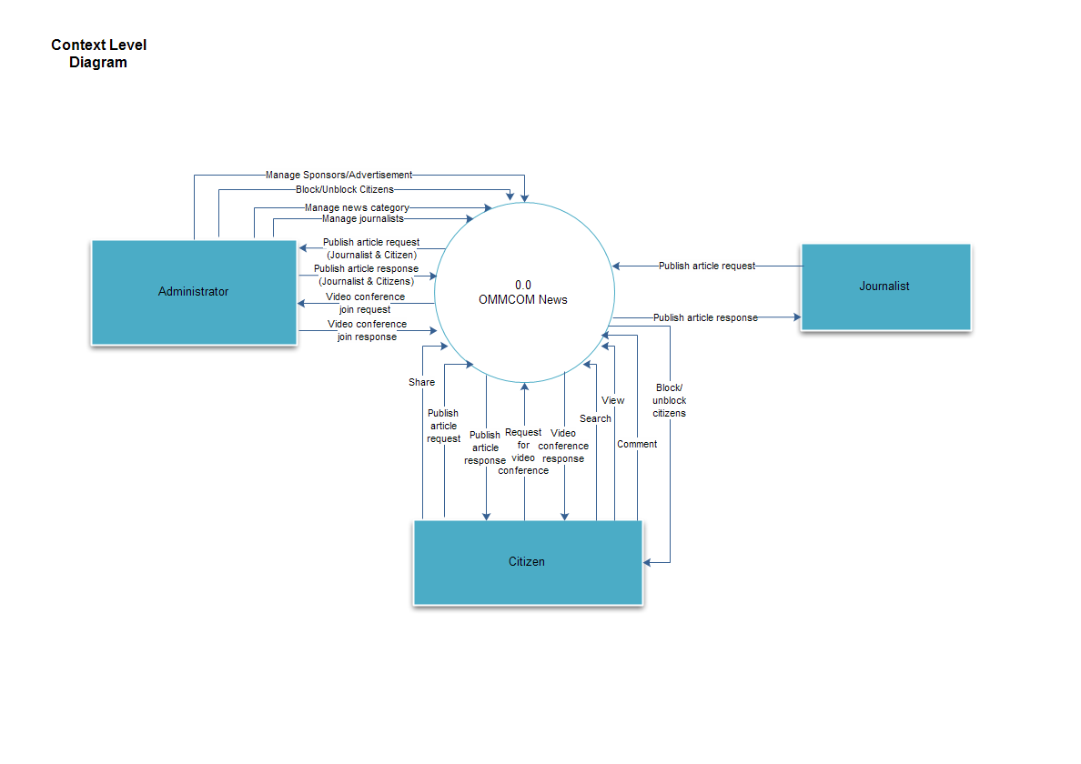

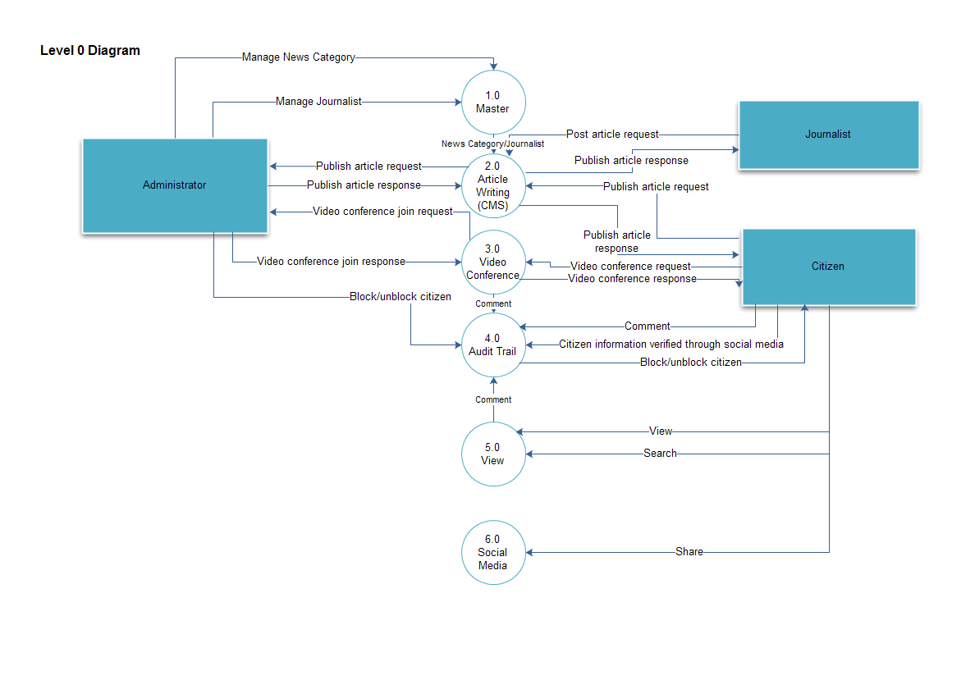

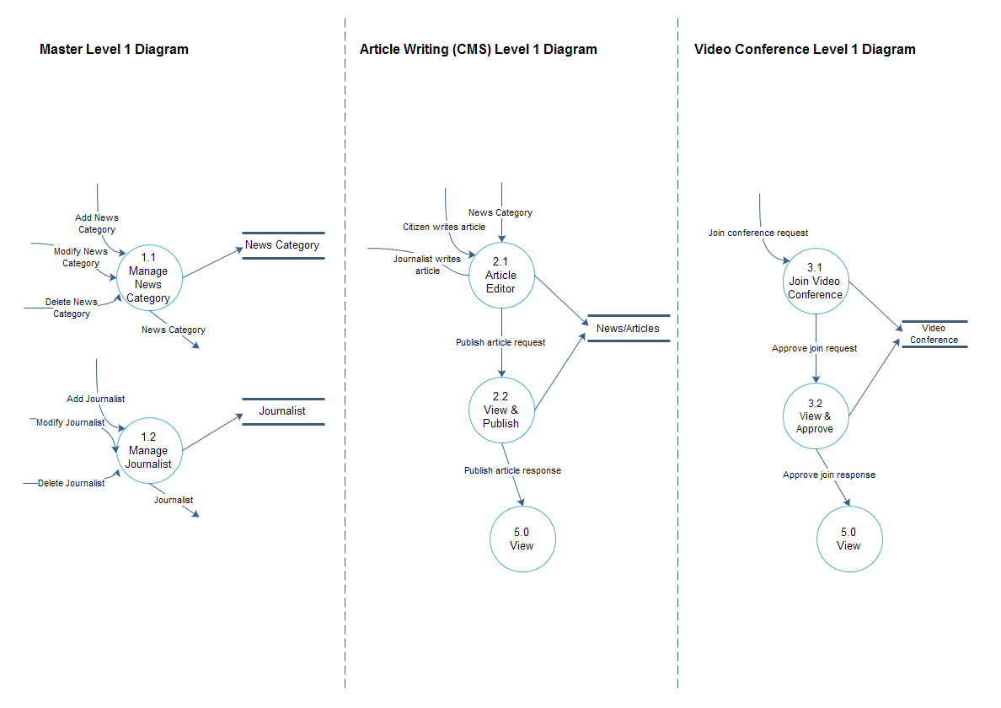

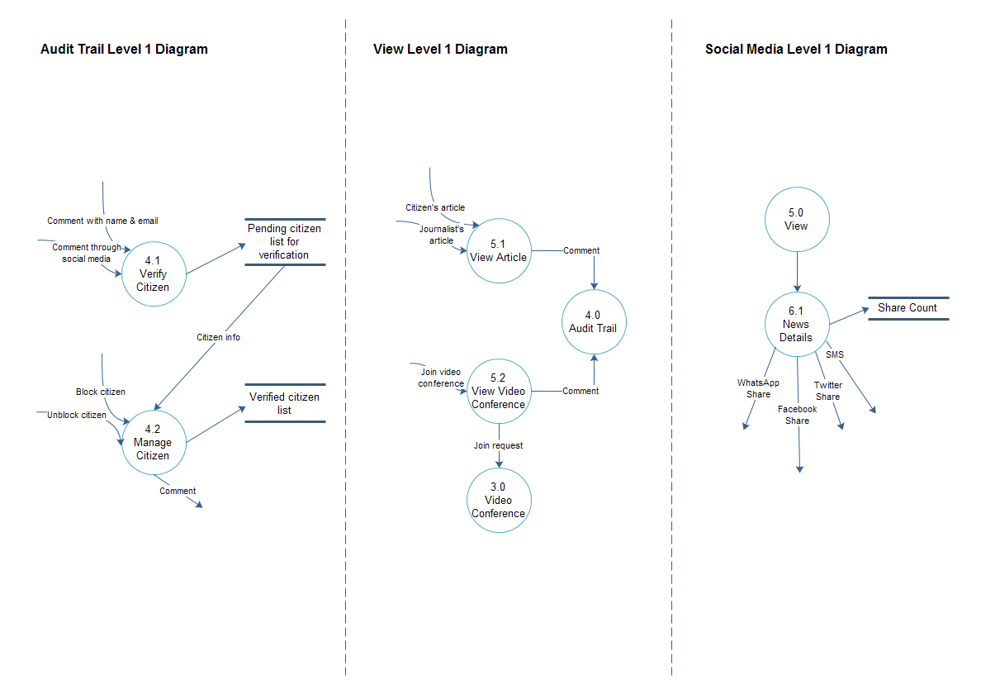

To Be Determined List
Not applicable.

